Cash Flows and Accrual Accounting
Income statement are prepared on accrual basis, not on cash basis and income statement primarily reflects events related to the operating activity of a business which is the reason why net profit does not necessarily increases the cash position of a company. It must be noted that a profitable year does not necessarily increases a company’s cash position nor does a company with an unprofitable year always experiences a decrease in cash.
Purpose of the statement of cash flows
The statement of cash flows is an important complement to the other major financial statements. The statement of cash flows reports the changes in cash over a period of time and most important, explains these changes. The statement of cash flow allows users to assess a company’s performance on a cash basis.
An example:
Consider the following discussion between the owner of Fox River Realty and the company accountant. After a successful first year in business in 1997, in which it earned a profit of Rs 1,00,000, the owner receives the income statement and Balance sheet at the end of second year as presented below: Fox River Realty
Income statement for the year ended December 31, 1998
Particulars | Amount
Revenues | 4,00,000
Depreciation expense | 50,000
All other expenses | 1,00,000
Total expenses | 1,50,000
Net Income | 2,50,000
Fox River Reality
Comparative Balance Sheets as on 31st December
Particulars | Amount(1998) | Amount(1997)
Cash | 50,000 | 1,50,000
Plant & Equipment | 6,00,000 | 3,50,000
Accumulated Depreciation | (1,50,000) | (1,00,000)
Total Assets | 5,00,000 | 4,00,000
Notes Payable | 1,00,000 | 1,50,000
Common Stock | 2,50,000 | 2,00,000
Retained Earnings | 1,50,000 | 50,000
Total equities | 5,00,000 | 4,00,000
Now, after looking at the statements the owner wonders where did the cash go? Accountant then explains the reason for decline in cash by preparing a Cash flow statement.

Fox River realty
Statement of cash flows for the year ended 31/12/1998
Particulars | Amount
Cash Provided (used) by operating activities:
Net Income | 250000
Add back: Depreciation expense | 50000
Net cash provided by operating activities | 300000
Cash provided (used) by investing activities:
Purchase of new plant and equipment | (250000)
Net cash used by investing activities | (250000)
Cash provided (used) by financing activities:
Additional investment by owner | 50000
Cash dividend paid to owner | (150000)
Repayment of notes payable to bank | (50000)
Net cash used by financing activities | (150000)
Net decrease in cash | (100000)
Cash balance at beginning of year | 150000
Cash balance at end of year | 50000

Cash and Cash equivalents:
According to accounting standards, certain items are recognized as being equivalent to cash and are combined with cash on the balance sheet and statement of cash flows. Commercial paper (short term notes issued by corporation), money market funds and treasury bills are example of cash equivalents. To be classified as a cash equivalent, an item must be readily convertible to a known amount of cash and have an original maturity to the investor of three months or less.
Classification of cash flows:
For the statement of cash flows, companies are required to classify activities into three categories: operating, investing and financing. Each of the three types of activities can result in both cash inflows and cash outflows to the company. There is a direct tie between the bottom part of cash flow statement and the balance sheet. The beginning and ending balances in cash and cash equivalent are taken from the comparative balance sheets.
Operating activities: Operating activity involves acquiring and selling products and services. A cash flow statement reflects cash effects either inflows or outflows, associated with each of these activities. For example the payment to supplier results in a cash outflow. The receipt of cash from collecting an account receivable results in a cash inflow. The income statement reports operating activity on an accrual basis whereas the statement of cash flows reflects a company’s operating activities on a cash basis.
Investing Activities: Investing activities involves acquiring and disposing of long term assets. Replacing worn-out plant and equipment and expanding the existing base of long term assets are essential to all businesses. In fact, cash paid for these acquisition results in cash outflow and sale of long term assets results to cash inflow.
Financing Activities: All businesses rely on internal financing, external financing or combination of both in meeting their cash needs. Issuing stock , bonds results in cash inflow and repayment of loan, payment of dividend, retirement or repurchase of stock results in cash outflow.
Classification of items on the statement of cash flows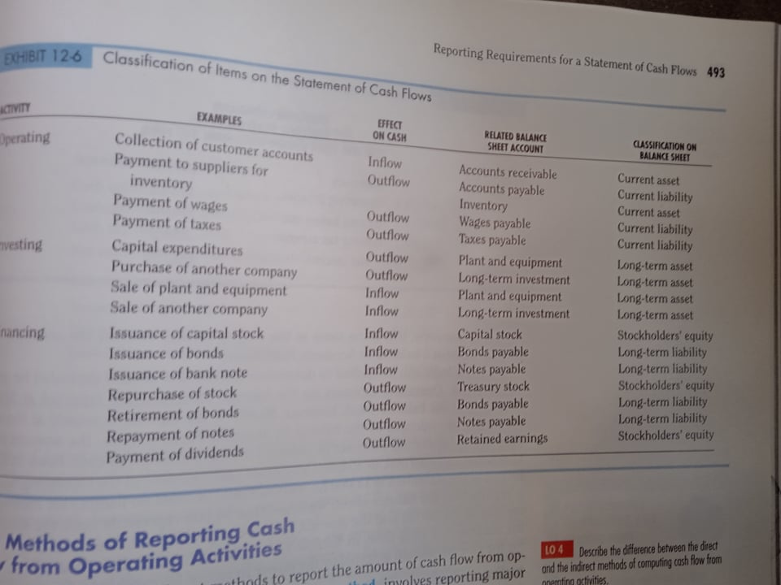

Statement of Cash Flows (Direct Method)
For the year ended …..Ashadh 20…
Particulars | Notes | Rs Current Year | Rs Previous Year
Cash flow from operating activities:
Cash receipts from customer
Cash paid to suppliers
Cash paid to employees
Cash paid for other expense
Interest paid
Income tax paid
Other receipts
Net cash flows from operating activities
Cash flows from Investing activities:
Proceeds from sale of PPE
Proceeds from sale of investment
Interest received
Dividend received
Proceed from sale of Subsidiary
Acquisition of subsidiary/PPE/Investment/Biological assets
Net cash flow from Investing activities
Cash flows from Financing Activities:
Issue of shares including premium
Dividend paid
Proceed from noncurrent borrowings
Repayment of noncurrent borrowings including premium
Increase/decrease in bank overdraft
Net cash flow from Financing activities
Net changes in cash and cash equivalents
Add: beginning cash and cash equivalents
Ending cash and cash equivalent

Notes:
1.1 Cash Receipt from customers: 1.4 Cash Paid for operating expenses:
Net Sales revenue **** Operating expense (excl. depreciation) (***)
Discount allowed (**) Increase decrease in prepaid **/(**)
Bad debts written off (***) Increase decrease in o/s expense **/(**)
Increase in receivable (***) (****)
Decrease in receivable ****
****
1.2 Cash Paid to supplier: 1.5 Interest paid:
Cost of sales (****) Interest expense (***)
Discount received **** Increase/decrease in o/s interest **/(**)
Increase/decrease in inventory (**)/** (****)
Increase/decrease in payable (**)/** 1.6 Tax paid
(****) Tax expense (***)
1.3 Cash paid to employees: Increase/decrease in tax payable **/(**)
Salary expense (****) (****)
Wages expense (****) 1.7 other receipts:
Increase/decrease in salary payable **/(**) Rent received ****
Increase/decrease in wages payable **/(**) Commission received ***
(****) Increase/decrease in accrued income (**)/**
****
2.1 Acquisition of PPE: 2.2 Proceed from sale of PPE:
Beginning balance **** Book Value of PPE ***
Depreciation expense (***) Loss on sale (***)
Sale of PPE(SP) (***) Gain on sale ****
Loss on sale of PPE (***) ****
Gain on sale of PPE *** 3.1 Dividend Paid:
Ending balance (***) Beginning R/E ***
Acquisition (***) Add: Net profit ***
Less: Ending R/E ***
Dividend Paid (***)

Q1) following is the financial statement of a company:
Particular | Amount (Rs.)
Sales revenue | 8,00,000
Less: Cost of goods sold
Purchasing | 3,00,000
Beginning inventory | 50,000
Less: Ending inventory | (80,000)
Wages | 2,10,000
Total cost of goods sold | 4,80,000
Gross profit | 3,20,000
Less: Operating expenses
Office and administrative expenses including depreciation Rs 50,000 | 1,70,000
Interest on debenture | 30,000
Premium on redemption of debentures | 10,000
Total operating expenses | 2,10,000
Operating profit | 1,10,000
Add: Profit on sale of plant (cost Rs. 1,00,000 Accumulated depreciation Rs. 40,000) | 20,000
Net income before tax | 1,30,000
Less: Income tax expenses | 40,000
Net profit after tax | 90,000

Balance Sheet
Assets
Particular | 2079 (Rs.) | 2080 (Rs.)
Land and building | 4,00,000 | 5,00,000
Plant and machinery | 5,00,000 | 6,50,000
Accumulated depreciation - plant | (2,00,000) | (2,10,000)
Inventory | 50,000 | 80,000
Accounts receivable | 50,000 | 70,000
Cash at bank | 20,000 | 40,000
Total Assets | 8,20,000 | 11,30,000
Liabilities
Particular | 2079 (Rs.) | 2080 (Rs.)
Share capital | 5,00,000 | 7,00,000
Share premium | 50,000 | 70,000
15% Debentures | 2,00,000 | 1,00,000
Income tax payable | 20,000 | 40,000
Accounts payable | 40,000 | 80,000
Bank loan | - | 50,000
Retained earnings | 10,000 | 90,000
Total Liabilities | 8,20,000 | 11,30,000
Required: Cash flow statement (Direct method) as per NFRS.
Q2) Income Statement for the Year Ended Ashad 31, 2nd Year
Particulars | Amount (Rs.)
Sales Revenue | 9,38,000
Less: Cost of goods sold | 5,46,000
Gross Profit | 3,92,000
Selling, general and administrative expenses:
Salaries and wages | 84,000
Depreciation | 56,000
Insurance | 16,800
Total operating expenses | 1,56,800
Operating Profit | 2,35,200
Other Incomes and Gains/losses:
Interest revenue | 21,000
Gain on sale of machine | 7,000
Loss on retirement of bonds | (4,200)
Net Income Before Interest | 2,59,000
Interest expenses | 71,400
Net Income Before Tax | 1,87,600
Income Taxes | 46,900
Net Income | 1,40,700

Balance Sheet as on Ashad 31, 2nd Year
Assets
Assets | 2nd Year (Rs.) | 1st Year (Rs.)
Cash and cash equivalents | 49,000 | 64,400
Accounts receivable | 88,200 | 79,800
Inventory | 117,600 | 128,800
Prepaid insurance | 16,800 | 25,200
Total current assets | 2,71,600 | 2,98,200
Investment in subsidiary company | 1,68,000 | 1,26,000
Land and building | 2,10,000 | 1,40,000
Property, plant and equipment | 4,48,000 | 3,92,000
Accumulated depreciation | (1,40,000) | (1,05,000)
Total long term assets | 6,86,000 | 5,53,000
Total Assets | 9,57,000 | 8,51,200
Liabilities and Stockholders Equity
Liabilities and Equity | 2nd Year (Rs.) | 1st Year (Rs.)
Accounts payable | 53,200 | 43,400
Salaries and wages payable | 9,800 | 12,600
Income taxes payable | 11,200 | 7,000
Total current liabilities | 74,200 | 63,000
Notes payable | 1,19,000 | 49,000
Bonds payable | 2,80,000 | 3,64,000
Total long term liabilities | 3,99,000 | 4,13,000
Capital stock | 1,40,000 | 1,05,000
Retained earnings | 3,44,400 | 2,70,200
Total shareholders equity | 4,84,400 | 3,75,200
Total liabilities and stockholders equity | 9,57,600 | 8,51,200

Additional Information
- Additional investment in the subsidiary company was made to the extent of Rs. 42,000.
- A piece of land was purchased by issuing a Rs. 70,000 note payable.
- A machine with an original cost of Rs. 49,000 having an accumulated depreciation of Rs. 21,000 was sold for Rs. 35,000.
- Machinery worth Rs. 1,05,000 was purchased during the year by paying cash.
- Bonds were retired at a premium by paying Rs. 88,200 in cash.
- Dividends of Rs. 66,500 were paid during the year.
- All capital stocks were issued for cash.

